Smart water management system

# 

# Introduction:

Smart water systems, often referred to as Smart Water Management or IoT (Internet of Things) Water Systems, represent a transformative approach to managing and conserving our planet's most vital resource is water.

Smart water systems are an essential part of the broader concept of "smart cities" and are becoming increasingly relevant in addressing water scarcity, infrastructure challenges, and sustainable water management practices.

Smart Water Management Systems play a vital role in addressing global water challenges and ensuring a sustainable water supply for communities, industries, and agriculture. These systems are key components of the broader smart city concept, contributing to improved urban resilience and the efficient use of water resources in a rapidly changing world. They represent a significant step toward a more sustainable and resilient future, where water is managed with intelligence, efficiency, and environmental responsibility.

# Project Objectives:

The primary objective is to create a smart environmental monitoring system that collects data from various IoT sensors, processes it on a Raspberry Pi, and allows users to access and visualize this data through a mobile app.

Monitor and collect data on environmental parameters like temperature, humidity, air quality, and light levels.

Provide real-time data access and historical trend analysis for users through a mobile application. Key Objectives:

# Key Objectives:

1. **Real-Time Data Visualization:** Provide users with real-time water consumption data from IoT sensors, allowing them to stay informed about water usage.
2. **Historical Data Storage:** Store historical water consumption data in a MongoDB database for analysis and reference.
3. **User Registration:** Implement a user registration system for personalized access to water consumption data and conservation tips.
4. **Water Conservation Tips:** Offer water conservation tips and information to educate and encourage users to reduce water consumption.
5. **Mobile App Development:** Develop a mobile application to extend access to water consumption data on mobile devices, enhancing user convenience.
6. **Efficient Water Distribution**: Ensure the efficient distribution of water by monitoring supply networks, identifying leaks, and optimizing water pressure and flow rates.
7. **Integration with Smart City Initiatives**: Align the project with broader smart city goals to enhance urban sustainability and resilience.
8. **Scalability and Replicability**: Design the project with scalability and replicability in mind to address water management challenges in different regions and environments.

## Creating a Real-Time Water Consumption Monitoring System

**IoT Sensor Configuration:**

The project involves the installation and configuration of IoT sensors, such as flow meters, in public places to measure water consumption. These sensors are connected to a central data-sharing platform that collects and transmits data in real-time.

**IoT Data Flow:**

1. IoT sensors measure water consumption.

Sensors

We have used the following sensors for our project:

Temperature

Humidity

Water Flow

Water Meter

Water Level

Leak Detection

1. The data is transmitted to a central data-sharing platform.
2. The data-sharing platform processes and stores the data in a MongoDB database.

The web application and mobile app retrieve data from the database for display

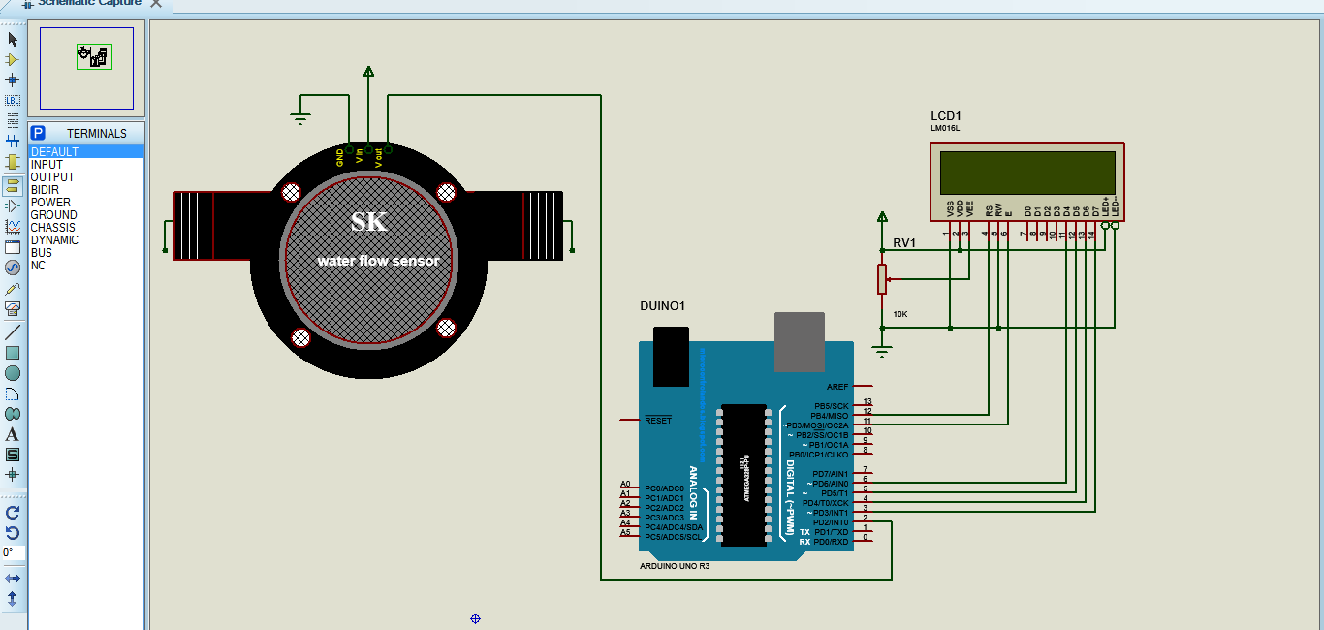

# 

**Mobile App Development:**

* A mobile app will be developed for both Android and iOS platforms. The app will allow users to access real-time water consumption data, historical usage trends, and set consumption alerts.
* Users can visualize their water usage through graphs and charts, receive push notifications when abnormal consumption is detected, and adjust their consumption habits.

Using programming languages such as Java and appropriate frameworks such as Android Studio

Implementing features for data visualization, user alerts, and data logging.

**Key Features of the Mobile App:**

**Real-Time Water Consumption Monitoring**: Users can view their current water consumption in real-time, allowing them to track their usage and make immediate adjustments if necessary.

**Historical Usage Data**: The app provides access to historical water consumption data, including daily, weekly, monthly, and yearly usage trends. This data helps users identify patterns and make informed decisions about their water consumption.

1. **User Registration:** Register and log in to personalize the app experience.
2. **Push Notifications:** Send users water conservation tips and alerts based on their preferences.
3. **Interactive Interface:** Provide a user-friendly and interactive interface for easy navigation and data visualization.
4. **Water Quality Information**: The app may display real-time water quality information, including parameters like pH, turbidity, and disinfection levels. Users can be informed about the quality of the water they are using.
5. **Leak Detection and Alerts**: The app can send push notifications to users when it detects abnormal water consumption or potential leaks. Users are alerted to take immediate action.
6. **Bill Payment and Payment History**: Some apps allow users to make bill payments directly through the app and provide access to payment history.
7. **Offline Functionality:** 19. Offline Data Access: Offer limited functionality in offline mode, ensuring users can access essential information even without an internet connection.
8. **Localization and Accessibility:** 20. Multiple Languages: Support multiple languages and localization to cater to a diverse user base.

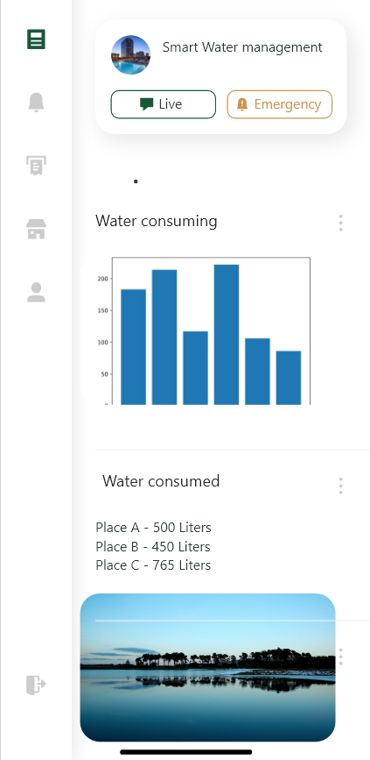

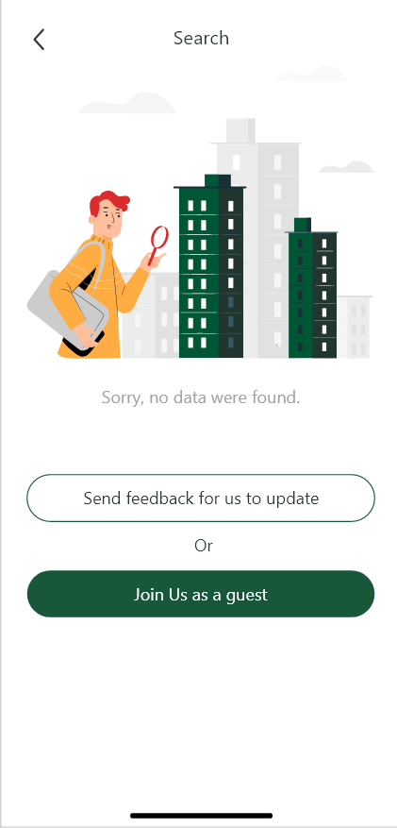

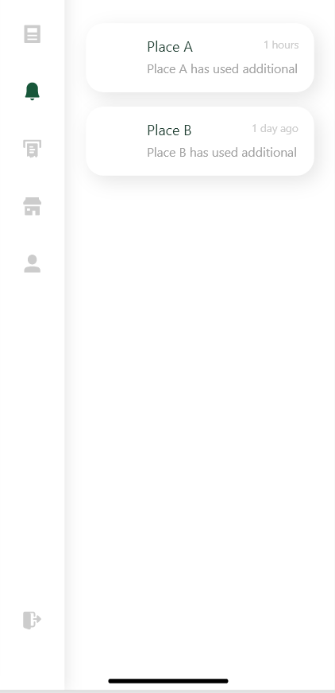

# Code Implementation

**Web Development Technologies:**

* **HTML, CSS, and JavaScript:** The project utilizes these core web development technologies for building the user interface.
* **React.js:** React is used as a JavaScript framework for creating a dynamic and responsive user interface.

**Server-Side:**

* **Node.js:** The server-side development is powered by Node.js, which handles routing, API endpoints, and data interactions.
* **Express.js:** The Express framework is used to create RESTful APIs for communication between the server and client.
* **Mongoose:** Mongoose, an ODM library, manages interactions with the MongoDB database.

**Database:**

* **MongoDB:** MongoDB is the chosen database system for storing historical water consumption data. A suitable schema is implemented for data storage.

**Real-Time Data Handling:**

* **AJAX or WebSocket:** Real-time water consumption data is fetched from the server using AJAX or WebSocket, ensuring updates in real-time.

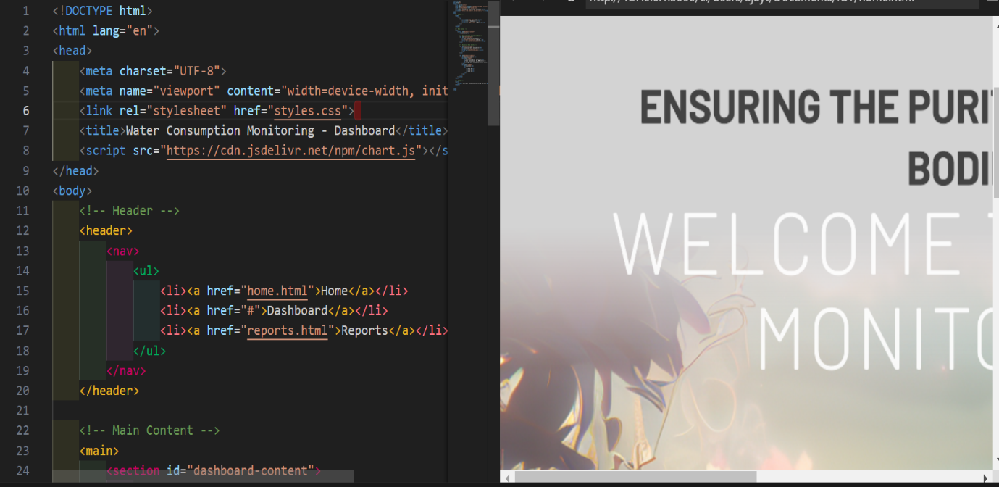

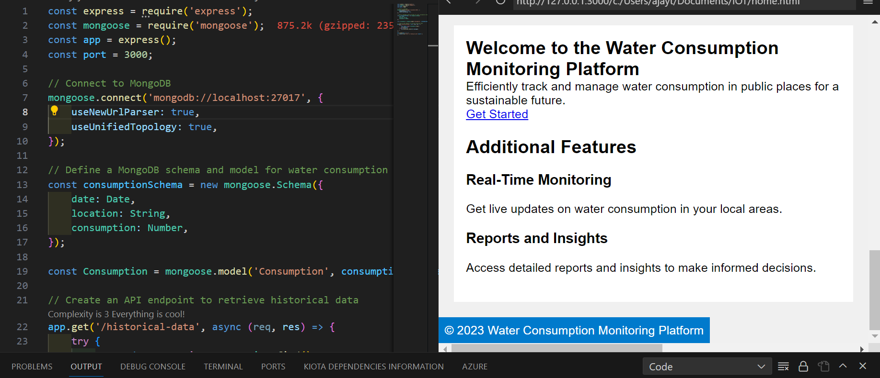

The project code implementation encompasses both server-side and client-side development, emphasizing real-time data retrieval, user registration, and data presentation. The use of a MongoDB database supports historical data storage, while the mobile app extends the project's accessibility to mobile users. This multifaceted approach aims to meet the project's objectives of promoting water conservation through informed user interaction.

Replicating the Project– IoT Sensors and Platform

# IoT Sensor setup:

* We will deploy IoT water flow sensors at key water supply points within a building, such as the main water line and individual faucets and showerheads.
* These sensors will continuously monitor water flow and transmit data to a central server for processing.

# Here the simplified IOT sensor setup diagram for smart water management system:

Water Source

|

(IoT Gateway)

|

_________|_________|_________

| | | |

Reservoir Treatment Distribution End-User

Tank Plant Network Locations

| | | |

| | | |

Source Quality Flow Residential,

Water Sensors Sensors Commercial,

(Quality) | | Industrial

| | | Meters

| | | |

| | | |

| | | |

Pipes Chemicals Pressure Water Outlets

| Treatment Sensors (Faucets,

| (Chlorine, Showers, etc.)

| etc.) |

| |

| ___ ___ |

| | | | | |

|__|___|__|___|_____|

| | | | | | |

Pipe1 Pipe2 Pipe3 Pipe4 Pipe5

(Flow) | | | | |

Valve1 Valve2 Valve3

(Pressure)

# IoT Sensor Deployment

1. **Select IoT Sensors:** Choose the appropriate sensors for your project, such as GPS sensors for location tracking, temperature sensors for environmental monitoring, and any other sensors relevant to your transit information system.
2. **Connect Sensors:** Connect the sensors to microcontrollers or IoT devices (e.g., Arduino, Raspberry Pi, ESP8266) for data collection. Ensure power and data connectivity.
3. **Programming:** Write code to read data from the sensors, format it, and send it to a central server. You can use Python for coding the microcontrollers or devices.
4. **Data Transmission:** Establish a communication protocol (e.g., MQTT, HTTP) to transmit sensor data to a central server or cloud platform. Python libraries like MQTT or REST APIs can be used for this purpose.

# Developing the Platform:

1. **Database Setup:** Create a database to store the incoming sensor data. You can use databases like MySQL, PostgreSQL, or NoSQL databases, and interact with them using Python libraries like SQLAl chemy.
2. **Web Server:** Set up a web server using Python frameworks like Flask, Django, or Fast API to create APIs for data retrieval and interaction.
3. **Data Collection and Sensor Integration** : Develop the software infrastructure to integrate IoT sensors into the system. Implement secure and efficient data communication protocols between sensors and the central hub.
4. **Data Processing:** Write Python code to process the incoming sensor data, extract relevant information, and store it in the database
5. **User Interface (Web and Mobile Apps):** Develop user-friendly web and mobile applications to enable users to monitor and manage their water resources. Create intuitive dashboards, real-time alerts, and data visualization tools.
6. **Real-Time Monitoring and Alerts :** Enable real-time monitoring of water quality, consumption, and system status .Implement an alerting system that notifies users and administrators of anomalies, such as leaks or water quality issues
7. **Scalability and Redundancy:** Design the platform to be scalable, allowing for the addition of more sensors and users. Implement redundancy and failover mechanisms to ensure high system availability
8. **Remote Control and Management:** Develop tools for remote system control and management, enabling administrators to take action based on real-time data.
9. **Regulatory Compliance:** Ensure that the platform complies with relevant water quality and data protection regulations and standards.
10. **Testing and Deployment :**Rigorously test the platform for performance, security, and usability .Deploy the system in a controlled and staged manner.

# Integration Using Python:

**Sensor Data Acquisition and Processing:**

1. Use Python to interface with IoT sensors and microcontrollers. Popular libraries like PySerial or Circuit Python can help in communicating with sensors via various protocols, such as UART, SPI, or I2C.
2. **Data Integration:** The Python backend of your transit information platform should continuously receive data from the IoT sensors and update the database
3. **APIs:** Expose APIs that can be used by the IoT devices to send data and by the user interface to request transit information.
4. **Data Analysis and Predictive Analytics:** Python's data analysis and machine learning libraries, such as NumPy, pandas, scikit-learn, and TensorFlow, can be used to perform data analysis and predictive analytics. For instance, you can build predictive models for water consumption trends or anomaly detection.
5. **Data Visualization:** Python libraries like Matplotlib, Seaborn, or Plotly can be used to create interactive data visualizations and charts for better data representation.
6. **Integration with External Data Sources:** Python can be used to integrate external data sources like weather data, geographic data, or water quality data into the system. Libraries like requests can help in making API calls to retrieve external data.
7. **Security and Authentication:** Implement secure authentication mechanisms using Python, such as user authentication and authorization. Python frameworks like Django have built-in authentication systems.
8. **Data Backup and Recovery**: Python scripts can be used to set up data backup and recovery procedures to protect against data loss**.**
9. **Testing and Deployment**: Thoroughly test the entire system to ensure it functions as expected. Once tested, deploy it on servers or cloud platforms to make it accessible to users.
10. **Remote Control and Management:** Python can be used to create remote control mechanisms that allow administrators to take actions based on real-time data.
11. **Monitoring and Maintenance:** Set up monitoring tools to keep an eye on the system’s health and performance. Regularly update and maintain the system as needed.

# Conclusion:

The success of this project will depend on the proper integration of these components and the effectiveness of the code implementation. Detailed design, hardware selection, and programming are crucial aspects to achieve the project’s objectives.

# 

# 

# 